**Output:**

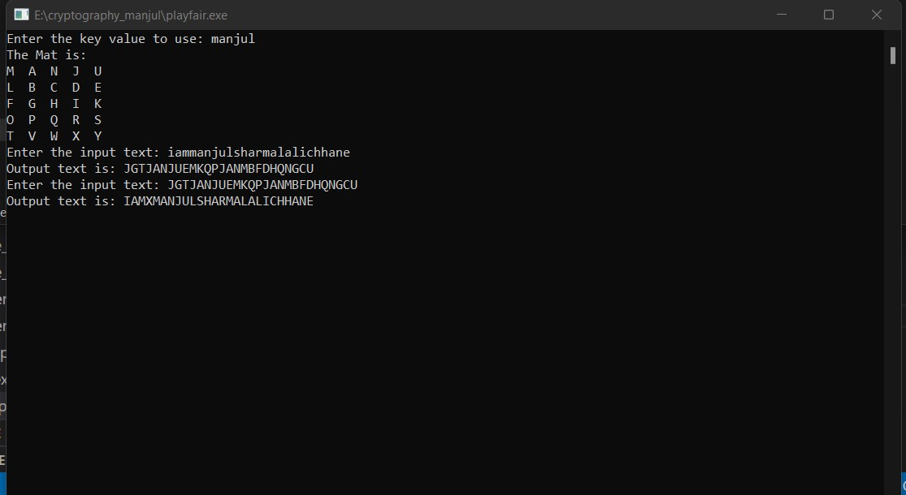

Fig: Play fair